- Name the following structures using IUPAC nomenclature [10 marks]
Structure | IUPAC Name
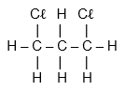
a)
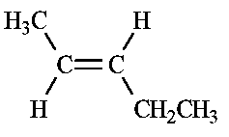
b)
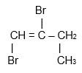
c)
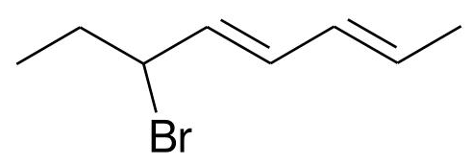d)
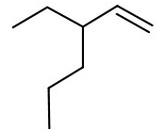e)
- Draw the following organic compounds [10 marks]

- 4,4-diethyloctane
- methylhex-3-ene

- Dichlorodifluoromethane

- 1-chloro-2-methylpentane

- Trans-but-2-ene

3. Complete the reactions below by drawing structural formulas or naming the substances as required. Afterwards, list the type of reaction and any observations that you would notice if doing this reaction. [9 marks]
a)
Type of reaction:

Name:
+ Br₂ →
Name:
Structural formula:

Observations:

b)
Name:
Formula:
+ I₂ → +
Type of reaction:

Observations:

